MODULE 1–ABOUT LABYRINTHS

WHAT THIS HANDOUT IS ABOUT

This briefing introduces what a labyrinth is, and offers little of the history, nature and examples of how labyrinths are used today.

In particular, we cover:

- WHAT IS A LABYRINTH?
- TYPES OF LABYRINTH – considering some of the more common labyrinth patterns that you may encounter
- PARTS OF A LABYRINTH – introducing some “labyrinth speak” to describe the different parts of a labyrinth
- LABYRINTHS THAT CAN BE WALKED WITHOUT MOVING YOUR FEET – considering labyrinths that need not be laid out on the floor or ground
- A BRIEF AND INCOMPLETE HISTORY OF THE LABYRINTH.

After working through this module, you should be able to describe what a labyrinth is, and appreciate some of the reasons why labyrinths hold such appeal today.

To work through the module:

  - Read and reflect upon THESE NOTES.
  - Watch the video: https://youtu.be/ZoW5OXBzufY [Click on the Settings button in the YouTube video window to select subtitles for your language]
  - Work through the REFLECTIVE EXERCISE.

CONTACT US if you have any questions, or reflections that you’d like to share.

1. WHAT IS A LABYRINTH?

- The labyrinth is a single path that leads anyone who walks it toward a centre. Unlike in a maze, there are no dead ends or blind passageways for getting lost. It is distinguished from a spiral in that it includes twists and turns in its path.

- The path may be painted, cut into grass, marked out with stones, be paved with polished marble, or countless other ways. Labyrinths can be permanently laid out, or temporary (mobile labyrinths, often painted on a canvas or other material, can be packed away and moved from place to place). They can also be of virtually any size, including small ones that you can sit on your lap for tracing with your finger.

- Labyrinths can be found in many parts of the world, and have a long history. Common patterns etched into the ground, paved in stone, or scratched out on walls have been discovered in many locations. As a nearly universal and ancient symbol that seems to have a powerful positive affect on anyone that walks it, the labyrinth is often referred to as an 'archetype', or something that speaks to us at a level that's hard to logically explain.

- Labyrinths have been particularly popular during different periods in history. Labyrinths feature in many Roman mosaics, while by the 13th century C.E., they had been incorporated into the floors of a number of northern Europe’s great cathedrals.

- Labyrinths are not owned by any one culture or religion. Ancient examples are found in most continents, although their purpose remains a mystery. Labyrinths have certainly been used for ceremonial purposes, as well as serving as gathering places. Most commonly, they have been used for walking (in earlier times, often as part of a pilgrimage, but now, most normally for meditation, reflection, and as a simple escape from the busyness and concerns of everyday life).

Appeals of the labyrinth

- An increasing body of evidence supports the healing qualities of labyrinth walking. In an examination of published research, Dr Herbert Benson of Harvard Medical School’s Mind/Body Institute is convinced that such practice leads to both reduced blood pressure and improved respiration rates. Chronic pain, anxiety, and insomnia, are among other conditions that available evidence strongly suggests are reduced through regular walking of a labyrinth, quite apart from the obvious relaxation benefits.

- Similarly, an extensive review by John W. Rhodes of 16 studies that had explored the positive
affects of engaging with a labyrinth adds weight to the suggestion that labyrinth walking offers many potential benefits.

- At the Myanmar Institute of Theology, for example, a labyrinth was created by faculty, staff, and students, with the main purpose of fostering the spiritual life of the community. The labyrinth was laid out with a prayer that those who walked it would find a connection with God. Within a short time of it being completed, individuals began reporting incidents of healing as a result of walking the labyrinth’s path. One man who had been suffering irregular heartbeats reported that his heartbeat had returned to normal after his encounter with the labyrinth; a woman reported feeling 'lifted up' when she walked, despite having a weak heart and doubting that she had the physical capacity to walk the path.

- A community-building focus has also been important for many groups and organizations where labyrinths are used–including labyrinths that have appeared in university campuses, hospitals, and in the grounds of corporate headquarters.

Uses of labyrinths

- Labyrinths are used for many purposes–for resolving conflicts, helping people solve problems, for healing and therapeutic purposes, for team building and community building. Most commonly, however, the labyrinth is used by individuals simply as a space for reflection, meditation, or to be able to step away from the busyness of the world for a short time.

- There are now thought to be more than 5,000 labyrinths in the United States alone. Many of these are portable labyrinths, painted onto a canvas mat or some other material, as in the case of the labyrinth that is being used for this project. This idea owes much to the work of Rev. Dr. Lauren Artress, who popularized the use of a canvas labyrinth at Grace Cathedral in San Francisco in the 1990s. The portability of this innovation became immediately popular, and spawned the creation of hundreds of similar foldaway labyrinths across the US.

- Many permanent labyrinth installations have also been created. Clubs, churches, temples, hospitals, town squares, public parks, prisons, and schools are among the many places that labyrinths can be found.

- Today, many people walk labyrinths to meditate, reflect, or detach from the everyday for a short while. Many people report feeling inspired, uplifted, having flashes of inspiration, but most commonly having a sense of peace when walking a labyrinth. Were it to offer nothing else, the labyrinth offers a safe space where you can be at one with yourself, not demanding anything from you other than that you put one foot in front of the other and breathe!

2. TYPES OF LABYRINTHS

- Labyrinths come in many shapes and sizes. Some have suggested that different patterns can have different affects on the people that walk them – that they tend to prompt different feelings, or bring different things to mind. In some cases, it seems that labyrinths have been designed with a particular purpose in mind.

- Labyrinths aren’t always circular in form, neither are their paths always smoothly sinuous. The installations at the cathedrals in Amiens, France, and Ely, UK, for example, display a very angular pattern. Nevertheless, a well-defined perimeter contains these and all labyrinths, and it will be apparent to any walker who walks them that they are moving around and ultimately toward a center.

- Many labyrinth designs, such as the familiar pattern seen in the medieval style, involve frequent turns that take us back in the direction from which we’ve just come. An ingenious feature of the Medieval (Chartres) pattern is that its sinuous path at times comes close to the center, and then takes a walker away toward the outer edge again.

- A so-called "processional" labyrinth has a different path leading into the centre than the one leading out. The "Baltic Wheel" is one such type of labyrinth. These allow for a “procession" of people to walk through the labyrinth, without people needing to pass by others walking in an opposite direction. They lend themselves to ceremonies, where such a procession is intended, which may include what might be called "ritualistic dances".

- Elsewhere, there may be far more practical reasons for designing labyrinths the way that they are. Routing a path around a tree, or fitting one into a particular shape and size of available land, are examples.

- Labyrinth paths have also been drawn to map out on the ground a logo or design representing friendship between two places (for example, a logo of two ”twin towns" in different countries), to be used for a special purpose, such as in conflict resolution and reconciliation, or simply to be artistically creative and pleasing.

- The Classical (sometimes also called ”Cretan" style), Medieval (including the 11-circuit "Chartres" design found at Chartres Cathedral), and "Baltic Wheel" patterns of labyrinth are perhaps the most commonly found.

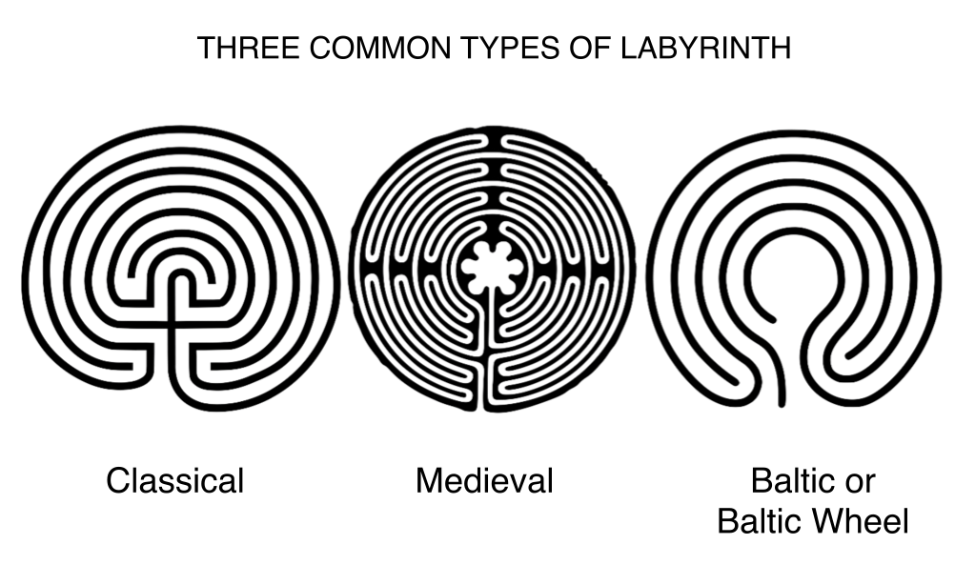

- Others, such as the "Man in the Maze" type, are also well known (the “Man in the Maze” in particular among Native American communities).

- What is interesting is that what may not appear to be a particularly obvious pattern to draw, notably the Classical type, crops up in many designs of labyrinths that have been found in different locations

throughout history. It seems that the different people who created these were drawing on some special knowledge or inspiration–although this remains a mystery!

- Other types of Labyrinth that are quite commonly encountered include the Santa Rosa, swastika, and Roman ‘meander’ type. Download Jeff Saward’s paper, ‘Mazes or Labyrinths… What’s the difference & what types are there? for more information.

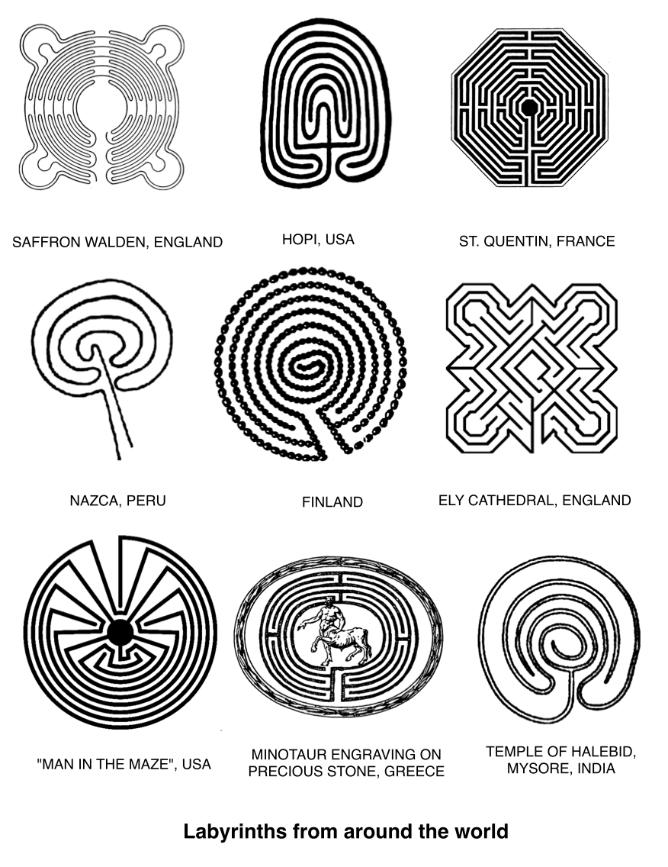

3. PARTS OF A LABYRINTH

- You may come across various terms that are used to describe parts of the labyrinth. The following are particularly common:

  - Path–the labyrinth’s route from the threshold to its centre
  - Threshold – the entrance/exit to the labyrinth, the point at which we step to or from the outside world into the labyrinth’s special or ”sacred” space

  - Centre – the ultimate point that we come to if we follow a labyrinth’s path. The centre is sometimes associated with ”coming home”, or completing a journey. One metaphor for the labyrinth’s path is for life as a whole (the Tohono O’odham people especially believe this).
Hence, coming to the centre is seen by some as coming to a point of unity, harmony, or fulfillment in life
  - Processional labyrinth–a labyrinth that has a separate path into the centre from that that leads out. This lends itself especially well to using the labyrinth for ceremonies, and if many people are walking into it and out of it at the same time
  - In-walk – the walk from the threshold into the center, contrasting with the walk outward or Out-walk.

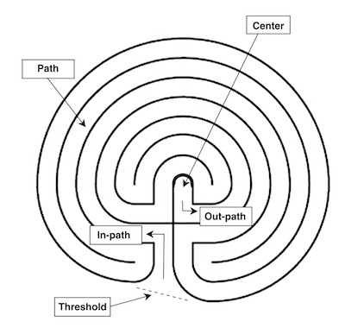
Parts of a Classical labyrinth

- In the Mediaeval type of labyrinth, the following terms are often used:

  - Lunation –the half circles, or “cups”, around the edge of the labyrinth. While we do not know whether the lunations served any purpose besides design, one modern if unlikely theory is that they could have been used as a lunar calendar, to allow the date of Easter to be calculated (along with other information). The rugged pattern around the edge of the Chartres labyrinth is sometimes also called a crenellation (similar to the tops of the defensive wall of a castle keep, and compared with the walls of Jerusalem) or dents (French, “teeth”).
  - Labrys – a double axe shape that’s particularly associated with the Minoan civilization, which gave birth to the story of the Minotaur and the labyrinth
  - Rosette –the petal pattern that rings the centre of the labyrinth, which in the Christian tradition is often associated with the Virgin Mary, and in many Eastern traditions, is associated with the petals of the lotus flower.

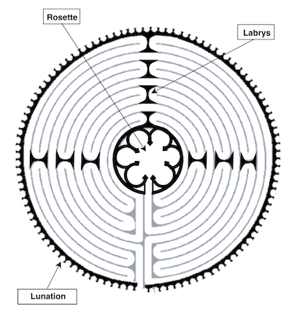
Parts of a Chartres labyrinth

4. LABYRINTHS THAT CAN BE WALKED WITHOUT MOVING YOUR FEET

- ‘Walking’ a finger labyrinth is one possibility for individuals who are short of space, or who are physically unable to walk a traditional labyrinth. In this labyrinth, the path is drawn on paper, or as a groove, typically carved into wood, molded in ceramic, or crafted using some other material, and the means for locomotion is by moving a finger, as opposed to the feet and legs.

- Finger labyrinths of different sizes and weights are available from online stores and elsewhere. Most are designed to sit in the lap or to rest on a small side table. Their slim form makes them easy to store, although they may also serve as an attractive table decoration. Labyrinths made from paper and other craft materials are easy to make.

- Finger labyrinths also have an important role to play in allowing people who might not otherwise be able to walk a ground labyrinth to share in this precious experience, including those who are bed-bound or blind. Neal Harris, https://www.relax4life.com/instructor/neal-harris/, a professional counselor, finger labyrinth creator, and a founding member of The Labyrinth Society, has used hand labyrinths in various therapeutic settings for more than twenty years.

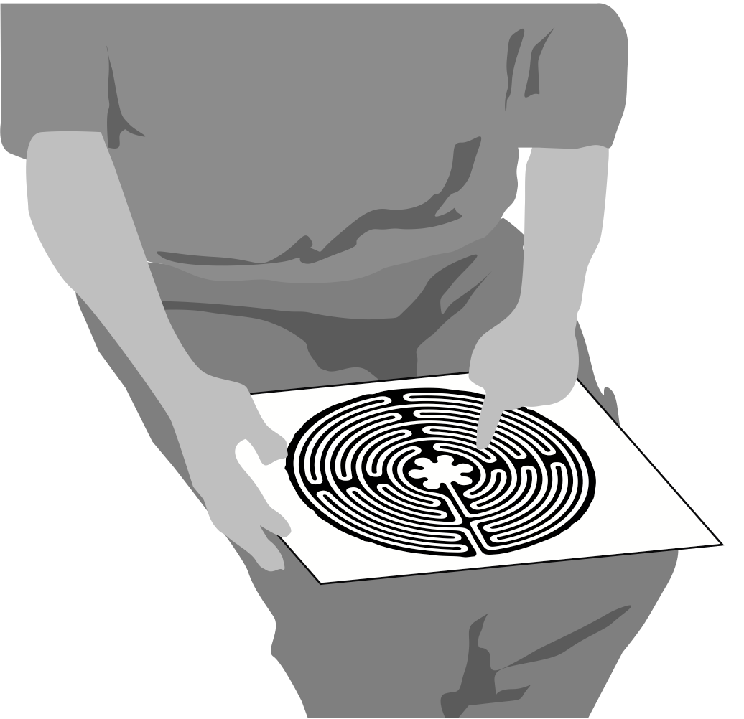

A finger labyrinth requires very little room to store and can be used by the home-bound

- Harris’ work led him to pioneer a double labyrinth, involving the use of both hands (or being used by two people), which helps to balance the activity of the right and left hemispheres of the brain.

Walking such a labyrinth has helped stroke patients who have suffered brain damage to heal, among others.

- Finger labyrinths have what may be an advantage over their larger cousins–offering a walker the ability to close their eyes while they are walking if they wish, which for many people can be an aid to avoid distraction during their meditation.

- A labyrinth that can be traced using a finger need not be carved in wood or stone. A path drawn on a sheet of paper can serve the same purpose, not to mention one embroidered onto a cushion cover or rug, projected onto a wall (or even a swimming pool, in the case of a special event staged at Nottingham University), made with string or wool and a sheet of card, or temporarily marked out in a sandbox.

- Labyrinths have been crafted into pottery, knitted into blanket squares, and carved with a finger out of play dough. Lisa Moriarty’s portfolio (http://www.pathsofpeace.com/photogallery.html#http://www.pathsofpeace.com/photogallery) even includes a labyrinth that was cut into a pumpkin–a special creation for Halloween! There really is virtually no limitation to what might be used for creating a labyrinth!

- A labyrinth that’s depicted on a poster, or that’s projected onto a wall can be ‘walked’ not only by tracing its path with a finger, but also by following its course with the eyes. Such an approach may offer a means of connecting with the labyrinth’s path for someone who is paralyzed, not to mention anyone who may be able to find a small space of wall on which to pin a labyrinth drawing.

5. A BRIEF HISTORY OF THE LABYRINTH

- Labyrinths have a very long history. We simply don’t know how ancient this history is, and fresh discoveries are still being made.

- A famous tale from Greek mythology tells the story of the Athenian Theseus, who with the help of a sword and a ball of thread gifted to him by the love struck daughter of the Cretan King Minos, Ariadne, manages to overcome a fearsome monster that’s trapped at the center of a supposedly inescapable labyrinth. After defeating the Minotaur, Theseus retraces his steps by following the thread that has unraveled on his inward journey, the other end of which had been tied at the labyrinth’s entrance. The pair then flee to the island of Naxos, leaving Minos in a fury, and vowing to punish the labyrinth’s creator.

- This labyrinth was designed by Daedalus, an ingenious inventor, as a means for housing the Minotaur, which Minos was ashamed to present as his son. Each year, seven young men and seven young women were sent from the mainland as an offering to satisfy the Minotaur’s insatiable appetite. Following Theseus’ solving of the labyrinth’s riddle and overpowering the Minotaur, Daedalus made to flee Minos’ kingdom, but the furious king banished him to an impregnable tower as a punishment for his supposed assistance for Theseus. We encounter him again in the story involving his son Icarus, who famously flew too close to the sun, causing the melting of the wax on the wings that his father had made for him as a means for escaping their imprisonment in the tower.

- Daedalus’ ‘labyrinth’ may be what we now call a ‘maze’. It may have included many dead ends and crossroads, designed to keep the Minotaur safely imprisoned at its center, as well as to trap anyone who dared to wander in. However, Theseus found the one true path–the labyrinth–which doesn't set out to entrap nor fool those who tread its path. Modern puzzle mazes incorporate the same principle–for those who know their secret, there is a single, if complicated, path to the center.

- Various civilizations are known to have used labyrinths around the same time as the Greeks.. For example, the story in the epic Mahabharata of Abhimanyu, son of the great Hindu warrior Arjuna, tells how the young man is taught how to make his way onto the battlefield and shown how to defeat his enemies, but not yet how to return. The tale is depicted in Hindu lore as a labyrinth, which bears a striking similarity to the Classical style, albeit being a distinctive variant of the classical pattern.

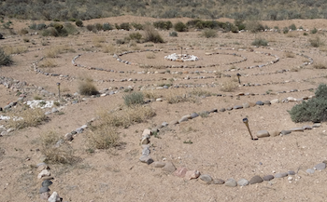
A Chakra-Vyūha labyrinth, with a central spiral of 3 rings

- The Hindu version, known in Sanskrit as Chakra-vyūha (literally, ‘wheel-battle formation’), represents the arrangement of troops in a labyrinthine pattern. It is found in numerous reliefs, as well as in Hindu, Tantric and Jain literature.

- Ancient labyrinths were typically marked out in stone on the ground, or formed a motif in a floor mosaic; garden mazes with hedges appear to have been an invention of the later Renaissance period in Europe.

- In contrast with a maze, a labyrinth has only one path (at least normally). Even where two or more paths are offered as a means of entry–as is the case with some specially designed labyrinths–any path that is followed leads to the labyrinth’s center. This is the point: there is nothing to worry about, except to follow the path and trust that it will take you to where you need to go.

- Theseus’ defeat of the Minotaur is thought to have been regularly enacted by the Greeks and later by the Romans in the so-called 'crane dances' around a labyrinth, also recalling the Greeks’ triumph at Troy, and so also known as the ‘Game of Troy’. This gives us a further example of the uses to which labyrinths have been but – for ceremonial and celebratory purposes. Some early Christians adapted the myth of Theseus to portray the perils of hell that face those who don’t follow the single path. Their encounter with the center was to be devoured, not saved. However, it’s fair to point out that Christians also believed that the labyrinth is an allegory of the soul’s path toward a New Jerusalem, and that only the unfaithful could expect their journey to end with a descent into hell.

- Generally, from the time of the Romans onward, labyrinths have been considered a space for protection. They are a safe space that holds us, even as we come into touch with our inner lives. The same is true of standing stone circles, forest groves, and circles of people – all are seen to contain a positive energy, being held by a spirit of compassion.

- Happily, the labyrinths of today usually have no Minotaurs pounding the ground at their centers. Rather than being spaces that overwhelm us, they are places for discovery and growth. As Hermann Kern so aptly says: “In the labyrinth you don't lose yourself. You find yourself.”

- The Classical form of labyrinth (not the type that sets out to ensnare) is a pattern that's often found today. Similar patterns have been found in labyrinths discovered in North America and India.

- Examples of the Classical pattern can be found in Jain, Hindu, and Buddhist manuscripts, as well as designs seen in Java, Nepal, and Afghanistan.

- Labyrinth petroglyphs (rock carvings) in Galicia, north-west Spain, are thought to date to the early Bronze Age, and labyrinthine patterns found on old Babylonian tablets can be dated with reasonable certainty to around the same period. Early Etruscan examples have also been found

- What is clear is that labyrinths have a very long history – longer than recorded history itself.

- Many mosaics from the Roman period incorporate elaborate labyrinth patterns in their design, characteristically representing an angular path, which is completed in a sequence by moving from one quadrant of the floor area to another.

- The Roman writer Pliny the Elder (23/24–79 CE) includes a list of architectural labyrinths in his ‘Natural History’, suggesting that labyrinths had more than aesthetic appeal for the Romans.

- The Austrian traveler Gernot Candolini recalls one explanation for this particular labyrinth’s significance from a man that he met at this sacred place during a tour of the labyrinths of Europe: “‘The labyrinth

is the belly of the mother’, the man asserted, ‘the umbilical cord leading to the earth’. ‘It’s the dance of the women’, said a woman, ‘and you men will never understand it’”. If it’s true that the labyrinth is “a symbol of the Earth, the womb of the soul, and a dancing ground”, as another observer mentioned, we can fairly say that the labyrinth has a powerful role to play in connecting us with the very ground upon which we walk, the provider of everything that we eat, and which offers us a sure base on which to build our homes – the home that some call Mother Earth, or Gaia.

- The history of labyrinths in the Americas remains a largely untold story. Drawings have been discovered in South America, while references among Native American peoples span several centuries. Labyrinth rock carvings are found in the south-western United States–notably in New Mexico and Arizona.

- The concept of the labyrinth as Mother Earth, the giver of life, is seen in many Native American representations. Spiritual rebirth, and the process of passing from one world to the next, are also considered important in the labyrinth’s symbolism for the Hopi people.

- Notable variations to the classical pattern are found illustrated in Native American petroglyphs and basketwork, including a square labyrinth with two entrances, and a pattern that combines both the familiar circuitous path of the classical labyrinth, along with what appears like a ‘spider leg’ distortion (see the diagram below). This so-called “Man in the Maze” pattern is the symbol of the Tohono O’odham people.
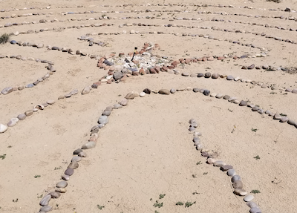

The “Man-in-the-Maze” labyrinth, with its distinctive wide
and angular turns

- In Europe, the labyrinth at the Cathedral of Notre Dame at Chartres in France (about 80 miles south-west of Paris) is particularly well known. The labyrinth that can still be walked here today dates from the thirteenth century.

- The cathedral was for many centuries an important destination for pilgrims. Visitors included those who were unable to journey to Jerusalem; the labyrinth instead offering a symbolic focus for a pilgrimage.

- Many are said to have walked the stone tiles of the labyrinth following long and arduous journeys to reach the hallowed town, with its imposing cathedral looming into view many miles before they reached their destination. For a pilgrim, to reach the center of the labyrinth at such a great cathedral was to arrive at the New Jerusalem.

- The design of the Chartres labyrinth is strikingly beautiful. Set into the pattern are 112 lunations, or ornamental motifs that mark the labyrinth’s outer-border. With near perfect symmetry, the labyrinth is as much a testimony to the grandeur and masterwork of this outstanding cathedral, as are the many stained glass windows that shine into its great space, including the exceptional rose windows

that bathes the north and south transepts, and the intricately crafted sculptures that adorn its exterior.

- It’s often said that the great rose window at the western end of the nave would transpose exactly onto the plan of the labyrinth were it able to be levered from its vertical plane onto the floor of the cathedral. However, the eminent labyrinth historian Jeff Saward has disproved this theory. Nevertheless, mysteries about the meaning of the labyrinth’s design continue to engage scholars, some suggesting that it may once have provided a space for enacting a ritual at Easter-time involving a ball, others speculating that it may have been used as an elaborate calendar.

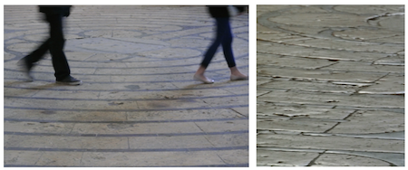
The 800 year-old labyrinth at Chartres Cathedral in France
can still be walked today

- The masterpiece at Chartres is one of a number of cathedrals, abbeys, and prominent churches surviving in Europe that are home to a labyrinth. Other examples include the labyrinths at Amiens, Poitiers, and Saint-Quentin (some replacing earlier labyrinths that had been destroyed).

- Elsewhere in Europe, labyrinths can be found in alternative settings, and–as far as we can tell–were used for differing purposes.

- Around the northern Baltic Sea coast of Scandinavia, for example, more than 600 labyrinths formed of stones have been found at locations that have become known as 'Troy Towns'.

- The labyrinths in Scandinavia all follow the classical or a spiral-based classical style. A variation to the design is found in labyrinths that have been found on the southern coastline of the Baltic Sea and in German-speaking countries of Europe, now commonly known as the 'Baltic Wheel' style. The proximity of the Scandinavian labyrinths to the coast suggests that they were important gathering places for fisher folk.

- Today, labyrinths appear to be more popular than ever before. It’s thought that more labyrinths have been created during the past thirty years than throughout all other human history. To some extent, this might not be surprising – the world population has grown exponentially over the past hundred years or so, and of course, we have more effective means for producing portable artifacts and communicating information about them than had our ancestors.

- In her book 'Walking a Sacred Path', Rev. Dr. Lauren Artress describes the unprecedented interest in the labyrinth at Grace Cathedral in San Francisco, which was first opened to the public just before New Year’s Eve, 1991.

- Such was the popularity of the labyrinth at Grace Cathedral, that Rev. Dr. Artress was soon asked to bring her ministry of labyrinth walking to many others across the United States, as well as around the world.

- The great innovation with the Grace Cathedral labyrinth was the use of a portable canvas – one that could be taken from place to place, being laid out as required, and then folded away again to allow the space that it occupies to be used for other purposes. Partly through Lauren Artress’ calling, and the earlier inspiration of New Age teacher Dr. Jean Houston, the labyrinth came to be re-established
as a well-known space for healing, meditation, reflection, community building, peacemaking, and many other purposes.

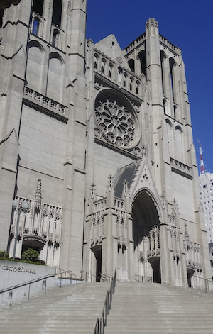
Grace Cathedral in San Francisco

- Labyrinthos (http://www.labyrinthos.net/ - http://www.labyrinthos.net/), an organization founded by labyrinth historians Jeff and Kimberly Saward, is the home for learning about the history of the labyrinth. Its extensive website of articles and photographs is supported by two annual journals, including Caerdroia, which publishes scholarly papers and research articles. Labyrinthos offers a wonderful treasure trove for discovering more about the labyrinth, and their website is well worth visiting and bookmarking. Click on the following link to go there: Labyrinthos.

GOING FURTHER

HANDOUTS that may help:

- Labyrinths: Ancient Aid for Modern Stresses, Karen Leland (article)
- 'Benefits of Labyrinths in Healthcare Settings' (article, The Labyrinth Society) [LINK]

ARTICLES and other RESOURCES:

- Labyrinthos http://www.labyrinthos.net/
- The Labyrinth Society Research Resources https://labyrinthsociety.org/useful-research-resources (references to research and articles concerning the benefits of labyrinth walking) [LINK]
- Relax4Life https://www.relax4life.com – website of Neil Harris, creator of the double finger labyrinth.

