MODULE 2–EXPERIENCING THE LABYRINTH

O QUE ISSO É SOBRE A EXECUÇÃO

This note covers the theme of experiencing the labyrinth.

We encourage you to take every opportunity to experience the labyrinth yourself, and suggest ways of doing this in this note. Without having experienced labyrinth walking yourself, you’ll not appreciate what a powerful experience this can be, and so would come to hosting others without an appreciation of what they may be experiencing.

If you are among friends, exploring the labyrinth for the first time, this may not be a difficult role to take on – especially if you are familiar with the concept of “holding space” (see Module 4, Hosting & Holding Space). However, it’s obviously preferable that you first walk a labyrinth yourself, or at least can share the role of hosting with a friend.

In this module, we consider:

  - How to access a labyrinth – finding, making, and improvising one
  - Experiences that you or others may have on the path, whether you walk a labyrinth alone or with others.

The topic of making a labyrinth discussed in this module is supported by the handout, MAKING A LABYRINTH http://www.labyrinthlaunchpad.org/LAB_FAC_TRG_MK_LAB_v01.pdf

After working through this module and undertaking the suggested exercises, you should be able to appreciate something of the mystery and power of walking a labyrinth.

To work through the module:

  - Read and reflect upon THESE NOTES and optionally, LINK (“Making a Labyrinth”).
  - Watch the video: https://youtu.be/LUE4L9yuZ98 [Click on the Settings button in the YouTube video window to select subtitles for your language].
  - Work through the REFLECTIVE EXERCISE.

Remember you can CONTACT US if you have any questions, or reflections that you’d like to share.

1. LOCATING LABYRINTHS

Labyrinths exist in many places, and one may exist close by where you are that you are able to walk.

Many are listed on the ‘Worldwide Labyrinth Locator’, https://labyrinthlocator.com/, a directory of known labyrinths that you can search on the Internet. Enter your location to see whether there might be a labyrinth close by where you are, and whether or not this is available for anyone to walk.

Other “locators” are available for different locations, including in Australia (https://aln.org.au/ ). See the Labyrinth Launchpad website for a full listing: http://www.labyrinthlaunchpad.org/llaboutlab.html#locators .

If you cannot find a labyrinth close to where you are, consider the options described in sections 2 and 3, below.

2. MAKING A LABYRINTH (TEMPORARY OR PERMANENT)

Labyrinths can be temporarily or more permanently marked onto virtually any surface in paint, using colored tape, bricks, rope, fallen tree branches, and virtually any materials that you might be able to find.

They may be painted onto a canvas, plastic sheeting, or sewn-together bed sheets, cut into grass or soil, or chalked onto a floor.

They may be of varying sizes, and their paths can be adjusted to fit whatever space they are being laid out in (for example, to pass around a tree).

Making a temporary labyrinth may take less than one hour, especially if you have another person to help you (although this isn’t necessary). If you cannot find a labyrinth close to where you are that you may be able to walk, making one is often much simpler than might often be imagined, and need not cost anything, if you can find natural materials to use.

See the separate NOTE http://www.labyrinthlaunchpad.org/LAB_FAC_TRG_MK_LAB_v01.pdf describing how to make a temporary CLASSICAL style labyrinth. This also lists many videos showing how to make different types of labyrinth.

3. IMPROVIZING A LABYRINTH EXPERIENCE

If you cannot find or easily make a labyrinth, you may still have a sense of what an encounter with the labyrinth may offer. The following are among possibilities:

- Drawing a labyrinth
- Walking a finger or wall labyrinth
- Making and walking a small stone labyrinth.

Drawing a labyrinth

The process of simply drawing a labyrinth can be very meditative, especially if you repeat this exercise a number of times. The “MAKE A LABYRINTH” note http://www.labyrinthlaunchpad.org/LAB_FAC_TRG_MK_LAB_v01.pdf shows the steps for drawing a Classical labyrinth, following the original design of Jeff Saward, however guidance is widely available on how to draw other types of labyrinth (see “GOING FURTHER”, below). Of course, once you have drawn a labyrinth, you can walk it with your finger.

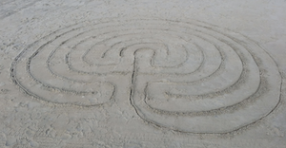
A Classical labyrinth drawn in the sand

Sadelle Wiltshire, a labyrinth artist based in Vermont, USA, offers regular on-line video classes in labyrinth art, including occasional introductory programs. Sadelle teaches how to draw many different types of labyrinth, including Medieval, Chakra Vyuha, and Baltic Wheel types. Visit https://sadelle-wiltshire-arts.teachable.com/ for more information.

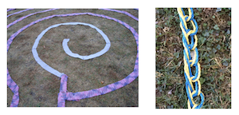
Crocheted rope and knitted labyrinth (photos by Carol Maurer)

Labyrinth painted on a bed sheet

Finger and wall labyrinths

The experience of using your finger or eyes to “walk” a finger or wall hanging picture labyrinth should not be under-estimated. This is a solitary walk–you will not need to pass others as you walk, nor not normally be aware of your relationship to others–but can be very meaningful, taking you away from busy mental thoughts to be at peace and at one with yourself.

A finger labyrinth may be created using any artistic materials, cut into a small sand tray, or simply mapped out on paper. If the labyrinth’s path can be felt (is not two-dimensional), you may like to close your eyes when following it, and noticing the experience that arises for you. Rope stuck to a card in the same way that you would lay out a large, floor or ground-based labyrinth (see above) is one way to quickly and simply make your own finger labyrinth.

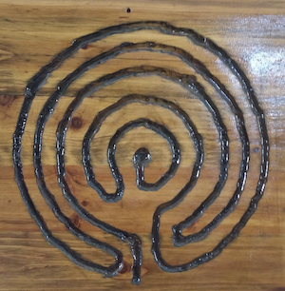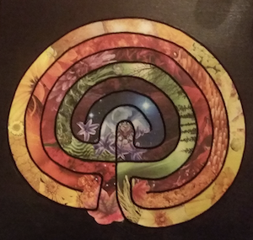

Finger labyrinths carved onto a piece of wood, and made with fabrics,
cut out and glued to card

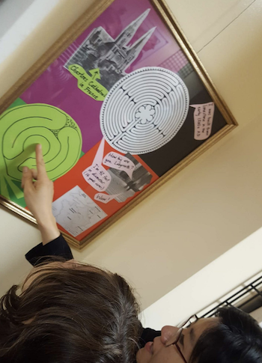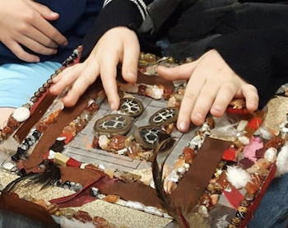

Walking a wall labyrinth, and a finger labyrinth made from felt and craft items

Making and walking a small stone labyrinth

A variation on making a finger labyrinth is to lay out a small outdoor labyrinth in a garden or public place using small stones or rocks. This may be too small to walk with your feet, but might be walked with a thin tree branch or beanstalk rather than your finger. The process of “walking” with a stick should engage more of your body than just using your finger alone, and you may notice a movement or subtle feeling within you as you do so. Don’t rush your walk – pay attention to it, and notice anything that arises within or for you as you do so.

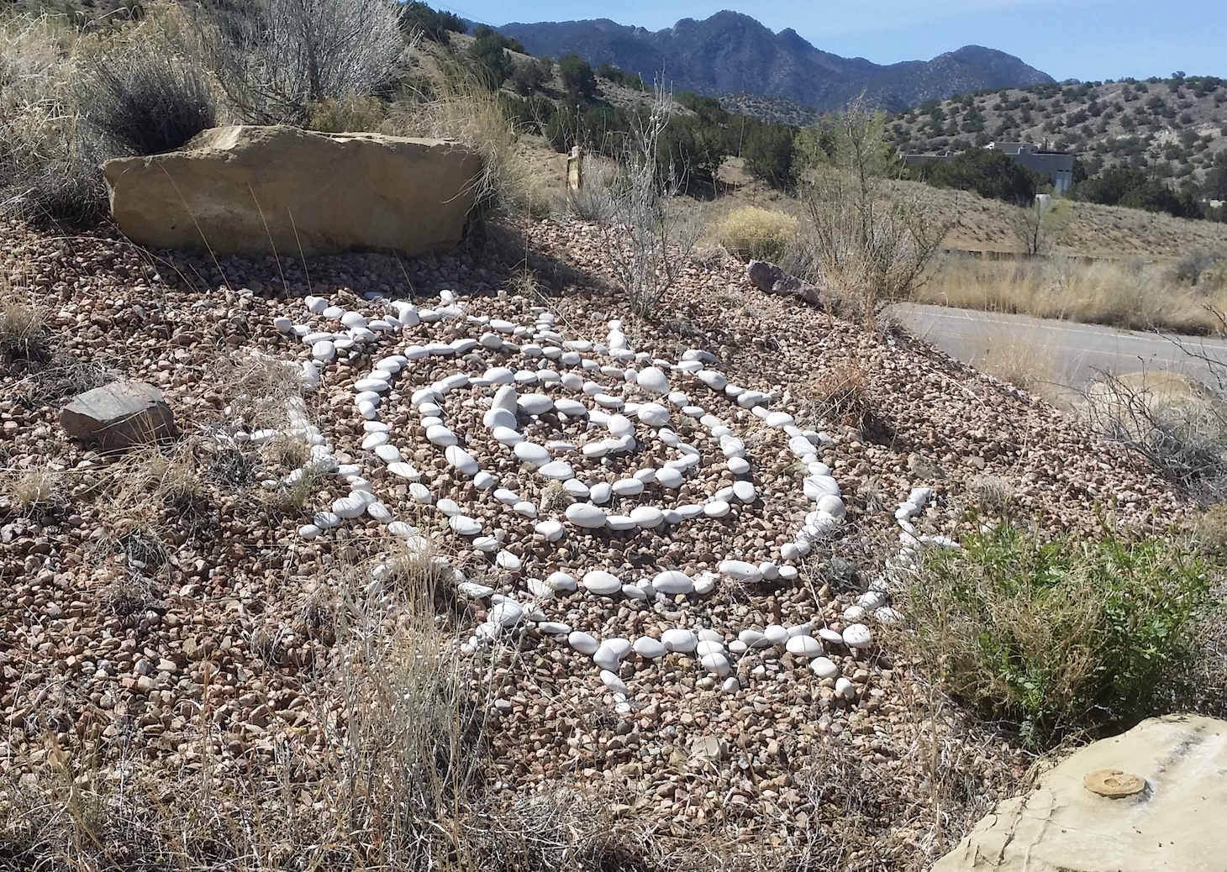

A small outdoor spiral, made of stones
(approximately 1.5 meters in diameter).

4. EXPERIENCES ON THE PATH

Walking a labyrinth often brings up different feelings, images, or thoughts. Usually, though not always, these are pleasant. An awareness of being on the edge of the labyrinth, coming to the center, or making a turn might all arouse different thoughts or feelings. You may remember things that you’ve forgotten, find inspiration, or simply just enjoy the peace of being “held” in a safe space for a short while.

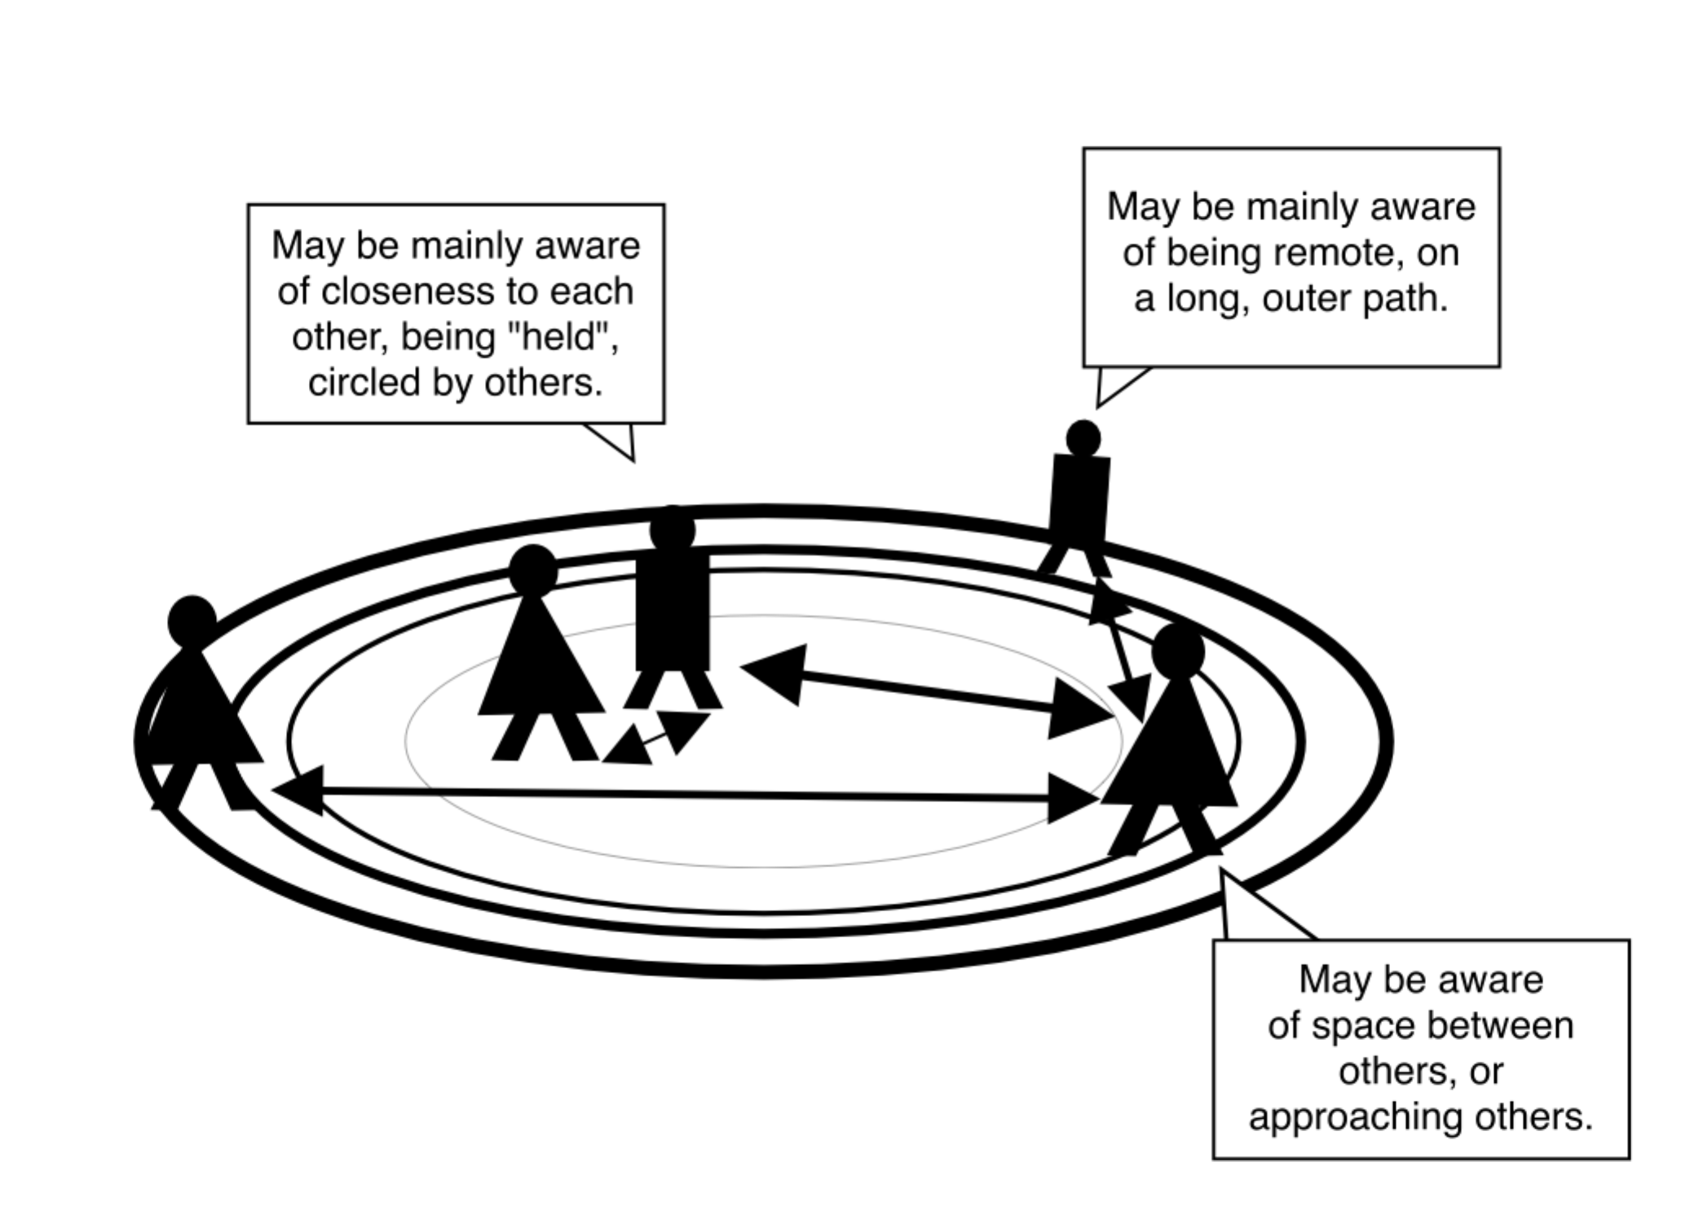
Becoming aware of the nature of relationships or
“constellation” with others can be an experience
in the labyrinth that causes different
thoughts or feelings to arise.

When others are walking the labyrinth at the same time, you may at times become aware of how they are moving or are spaced relative to where you are at any time–perhaps having a sense of closeness when you might rest with one or several others at the center, or remoteness when you are walking the path away from others. The subtle feeling of how you are in a dynamic “constellation” with others, if you experience this, will most likely change as both you and others move along the path.

Such sensations, as well as the surprises the labyrinth can bring–a sudden turn, being back near the edge of the labyrinth, or coming to the center–are sometimes likened to the twists, turns, and different experiences of the path of life.

Indeed, the Tohono O’odham people in the southwestern United States and northern Mexico, with whom the “man-in-the-maze” type of labyrinth is commonly associated, say that the labyrinth’s path represents life’s path, offering opportunities to look back as we move further toward our destination, turns at which we have a choice to turn back or to continue moving forward, and the reward of coming home (or dying to the worry of life, and restarting a new cycle) when we come to the center.

Every time you walk a labyrinth you may have a different experience. Similarly, we may never know what others are experiencing as they walk. Many people choose not to share what for them is a private experience, and of course, we should respect this. The labyrinth offers a single path along which every person’s journey is unique, yet a common center to which ultimately all may come.

INDO ALÉM

HANDOUTS that may help:

- Making a Labyrinth http://www.labyrinthlaunchpad.org/LAB_FAC_TRG_MK_LAB_v01.pdf includes a list of resources and VIDEOS showing how to make different types of labyrinth.

- Paper finger labyrinths https://www.relax4life.com/download-paper-finger-labyrinths/

ARTICLES and other RESOURCES:

- Worldwide Labyrinth Locator, https://www.labyrinthlocator.com/

- Sadelle Wiltshire Meditative Arts (check with Sadelle regarding ongoing availability):
https://sadelle-wiltshire-arts.teachable.com/ https://app.convertkit.com/landing_pages/448874?v=7 https://sadelle-wiltshire-arts.teachable.com/p/labyrinth-art-journeys-vol-1

