|  |
| --- |
|  |
| **INTRODUCTION** |
|  |

WHAT THIS HANDOUT IS ABOUT

This briefing **introduces** the Labyrinth Launchpad self-study program for discovering the labyrinth and holding walks.

In this note, we consider:

* + The objectives for the program
  + How the program works
  + The topics we will cover
  + Getting help.

After working through this module, you should appreciate what you should expect to gain from the program, and know how to approach our recommended path for self-study.

To work through the module:

* + **Read and reflect upon** THESE NOTES.
  + **Watch the video**:https://youtu.be/b8LCkdZZtTk . [Click on the Settings button in the YouTube video window to select subtitles for your language]

**CONTACT US** if you have any questions, or reflections that you’d like to share.

1. OBJECTIVES FOR THE PROGRAM

* This path of self-study is designed for anyone who is starting to explore the appeal of the labyrinth, and who wants to introduce the labyrinth or host labyrinth walks for others. It is intended to be self-taught, although help is available when you may need it. No previous labyrinth experience or knowledge is assumed.
* The general objectives for the training are as follows:
  + To enable you to appreciate a basic history, applications, and believed benefits of the labyrinth
  + To have sufficient knowledge and confidence to begin using and hosting others who may be new to labyrinth walking
  + To gain a sense of what it means to experience walking a labyrinth, and gain an appreciation of some of the experiences that others may have
  + To appreciate the wide scope of help and development options available to you as you continue to explore the labyrinth’s potential, including its use in community building and in a variety of professional contexts.
* By working through these modules, you will be able to:
  + Draw or build a simple labyrinth of your own
  + Plan and hold a labyrinth walk
  + Identify how you may wish to continue working with the labyrinth, and further options available to help you.
* The program is split into 5 modules, each covering a separate topic (see 3. PROGRAM STRUCTURE, below). These are intended to be worked through sequentially: starting with MODULE 1–ABOUT LABYRINTHS.

2. HOW TO APPROACH THE PROGRAM

* Each module is supported by a set of **notes**, an introductory **video** and a list of **references to other sources of help**. You are also encouraged to attempt a **reflective exercise** with each module, which suggests questions to consider and activities to undertake that will help increase your exposure to the labyrinth.
* To work through each module, fully read the notes and watch the video before attempting the reflective exercise. You may find it useful to read the notes more than once to properly familiarize with them.
* The notes may refer to handouts, website links, or other materials that are available online. Simply click on the highlighted text to follow the links. Handouts are formatted as PDF files, and should download to whatever your default downloads folder on your computer, phone, tablet, or other device is (they may not open automatically in a separate window, depending on the settings of your Internet browser or computer or other device). To read a PDF file, you will need to have ADOBE READER installed on your computer or whichever device you use to connect to the Internet. A link to download this for free is included in the section “GOING FURTHER,” below.
* Work through the program at your own pace. There need be no rush. You can of course come back to review any material that you have worked through previously if you wish.
* Self-reflection, trying things out, and gaining experience for yourself are among the most effective means for developing your labyrinth hosting practice. Go with what feels right, and you will find your way. Remember that each module includes a suggested exercise, including points to reflect upon and/or one or more activities to try.
* You may wish to make a dedicated notebook your place for noting your thoughts, questions, and responses to the reflective exercises as you work through the program.
* Since we are a volunteer organization, we have usually mixed professional and automated translation for the notes, which were originally written in the English language (the same applies to the video subtitles). We have attempted to use simple language throughout to improve the likelihood of a reliable translation, however realize that this will not be perfect. Please use your discretion when understanding the context of what is written, and of course, please do ask us if anything is unclear. We **greatly value any suggestions** for improving non-English translations that you may be able to suggest.
* The VIDEOS associated with each module are hosted by YouTube. YouTube offers a facility to display **subtitles** in a number of different languages, based on translations from the original English. To display these, click on the SETTINGS icon (which looks like a cogwheel), which is one of the 4 icons at the bottom right of the screen (see the diagram on the next page). Then select “SUBTITLES/CC” from the menu displayed, and then select from the list of available languages which you wish to view for the video. The audio for each video is in English.
* You may need to check that your SETTINGS have subtitles/closed captions (CC) switched ON, by clicking on the SETTINGS icon (next to the SUBTITLES icon), and then toggling ON the “SUBTITLES/CC” option if this is currently OFF. SETTINGS also allow you to **increase the font size**, and **change the color** of the font and the background that subheadings are shown against.
* You may also see the YouTube icon. If for any reason the video isn’t being shown on the YouTube channel, selecting this will show the video on YouTube. The final icon in the bottom right allows you to display the video to fill your screen (see the diagram on the next page).

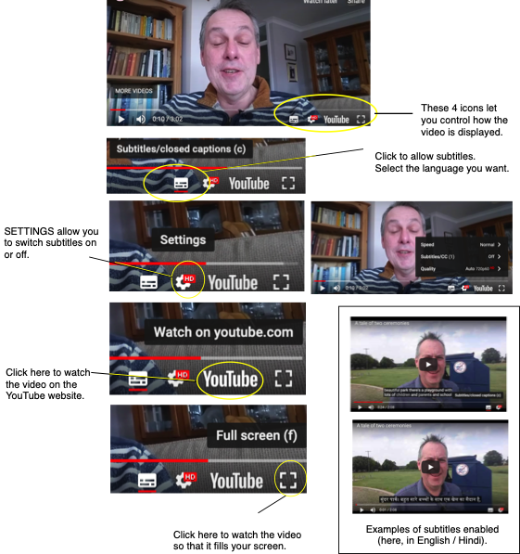

3. PROGRAM STRUCTURE

The program is organized as five modules:

* MODULE 1–ABOUT LABYRINTHS
  + Types, parts of the labyrinth, differences with mazes, finger labyrinths & others
  + Brief history
* MODULE 2–EXPERIENCING THE LABYRINTH
  + Accessing a labyrinth – making, finding, improvising
  + Experiences on the path – alone & with others
* MODULE 3–INTRODUCING THE LABYRINTH TO OTHERS
  + Planning needs – audience, available space, timings
  + Choosing the venue
  + Preparing what you say, how you introduce the labyrinth
  + Back-up resources, e.g. handouts, signage
  + Setting-up and packing down the labyrinth
* MODULE 4–HOSTING & HOLDING SPACE
  + Role of the host
  + Sacred space
  + Opening the labyrinth
  + Offering guidance for walkers
  + Managing the walk – entering the labyrinth, managing time
  + Attention to walkers, including interventions & handling emotions and the unexpected
  + Closing the labyrinth
  + Aftercare – for others & yourself
* MODULE 5–GOING FURTHER
  + Reflective practice & learning, supporting resources
  + Development options, the worldwide labyrinth community
* **These are** **intended to be followed in sequence**, as some subjects referred to in later modules are introduced earlier in the program.

4. GETTING HELP

* Please feel free to **email us** if you have any questions or comments as you make your way through the program. We may not reply immediately, but will respond when we are able. Contact us at **support@labyrinthlaunchpad.org**.
* Some labyrinth enthusiasts volunteer their time as supporters to anyone following this self-study path who wants to call upon them. Support is usually carried out via the Internet (via the video conference services Skype or Zoom–see below for links to download these). Their time is given freely, and cannot be guaranteed, however we will do our best to work with you at times that suit both you and ourselves. Several supporters speak different languages, although English is most common.
* We will endeavor to find an effective way for working with you when we do not share a common language. We do not pretend to be “experts”, nor that we understand your interest or context for discovering the labyrinth more than you do–we almost certainly don’t! However, we come with a desire to help and be a useful “buddy” or “second brain”, as well as to offer encouragement as you find your own way with the labyrinth.
* The support that we offer may include “holding” you remotely when you intend to walk a labyrinth, which may not necessarily involve being online at the time that you plan your walk (the meaning of “holding” is covered in MODULE 4).
* To request holding or support, email us at the address given above.

**WELCOME to the program. We hope you enjoy what you discover, and look forward to hearing your comments and helping you along the way!**

GOING FURTHER

HANDOUTS that may help:

* **Using Zoom** <https://www.context.org/help/zoom-quickguide/>

ARTICLES and other RESOURCES:

* Zoom download <https://zoom.us/download> (download via the iOS App Store or Google Play to download to your phone or other smart device)
* Skype download <https://www.skype.com/en/get-skype/> (download via the iOS App Store or Google Play to download to your phone or other smart device)
* Adobe PDF Viewer download <https://get.adobe.com/uk/reader/>