MAKING A LABYRINTH
CREATE AND EXPERIENCE WALKING YOUR OWN LABYRINTH

WHAT THIS HANDOUT IS ABOUT

This handout supports the video ‘Make your own labyrinth’, showing how to create a labyrinth that you can walk using simple materials.

Having experience of walking a labyrinth, ideally while being ‘held’ (supported by a labyrinth host) is obviously essential for appreciating why this can be such a powerful and special experience. Unless you experience walking a labyrinth yourself, it will be very difficult to ‘hold’ others who are doing the same!

1. NEED

- Labyrinths exist in many places, and one may exist close by where you are that you are able to walk. Many are listed on the ‘Worldwide Labyrinth Locator’, https://labyrinthlocator.com/, a directory of known labyrinths that you can search on the Internet. Visit and enter your location.

- However, there are many places where labyrinths aren’t available. In such cases, in order to experience walking a labyrinth, you will need to make your own, possibly a very temporary one.

- This isn’t difficult to do, and need not take much time. This handout – and the many videos listed in the ‘Further Information’ section – will show you how to create a labyrinth using simple materials that you may have to hand or be able to easily find, often with very little or at no cost.

2. THE ‘CLASSICAL’ LABYRINTH

- The Classical labyrinth pattern is one of the most common patterns of labyrinths found around the world. It is also one of the easiest to make or draw, as people have been doing for many centuries.

- The labyrinth usually has 7 rings (or circuits of the path), although fewer or more rings may feature, as space or another practical reason requires.

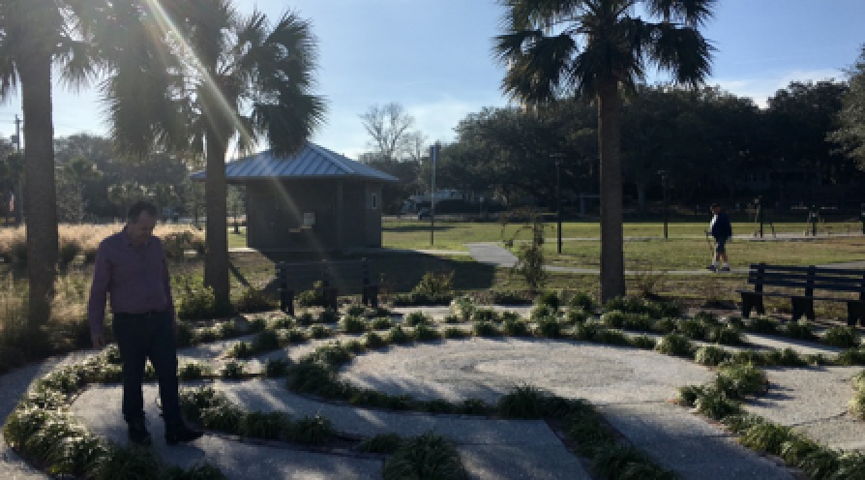
A Classical labyrinth.

- This pattern is sometimes known as the ‘Cretan’ type. The name ‘Cretan’ refers to the labyrinth mentioned in Greek mythology, built for King Minos of Crete by the brilliant inventor Daedalus (although this was almost certainly of a different design). This labyrinth was intended as an inescapable prison, to hold the king’s half-man, half-bull son, the Minotaur. Each year, the myth tells, seven young men and seven young women were brought from Athens to be offered as a sacrifice to the Minotaur. Athens had lost a war to Crete, and so was required to provide these poor souls. One year, the son of the king of Athens, Theseus, offered himself to join the party that was destined for the labyrinth. Upon arrival in Crete, King Minos’s daughter, Ariadne, fell in love with him, and was inspired to give him a ball of thread to unwind as he made his way into the labyrinth. Theseus killed the Minotaur, and then was able to retrace his steps by following the thread that had unraveled behind him, then escaping with Ariadne to a distant island.

- This story may be a myth, but it has translated into other cultures and faith traditions. In Christianity, for example, Theseus’s slaying of the Minotaur is seen as representing Christ conquering death.

- The supposed labyrinth made by Daedalus has never been definitely found, although several claims to its existence have been made (notably, at the Palace of Knossos). If it ever really existed, it’s unlikely that it would have the same pattern as the type known as ‘Cretan’ today – which has just one path into and out of the labyrinth, rather than being designed to trap and confuse anyone who entered it! Still, the single path marked out by the ball of thread is one that, when followed, leads to the center, or to the outside.

- The classical type has just one path in and out of the labyrinth – to exit, you return along the path that brought you in. There is quite a small ‘center’, more of an end of the path, but still if you are walking alone or with few other people, you might want to spend time here, before returning.

3. CHOOSING YOUR SPACE

- This labyrinth can be made either indoors or outdoors, although you will need at least a 12-foot (4 meters) square area to work with.

- Depending on what materials you use to mark out the labyrinth, the labyrinth can be made on soft or hard ground, on the floor of a building, or virtually anywhere. Try to find a fairly flat surface if you can, ideally without holes in the ground. The surface doesn’t have to be clean (e.g. free of tree leaves) – just so long as you can see where to mark out the path.

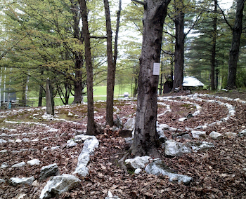
Labyrinths often sit well with, if respecting, trees

4. MATERIALS YOU WILL NEED

- Virtually anything can be used to mark out the path of the labyrinth – stones, tree branches, rope, tape, chalk, a path carved in loose earth using a stick…whatever is easily available to you! Several small objects are needed to mark 4 points of the labyrinth, such as stones.

- If you want to mark out the path carefully, you may want to use a ruler or other means for checking your measurements. Otherwise, a rough or approximate marking out is good, such as using your feet.

- Labyrinths may be intended to be very temporary (e.g. laid out, walked, and dismantled within a day). More permanent labyrinths may require more careful marking out, using materials that aren’t likely to be easily blown or washed away by wind and rain.

- Similarly, if you want to ensure that your path is perfectly curved, and its width consistent throughout, you may want to use a hand-made ‘compass’, such as large stick with a string pulled tight to it, to mark out the path. If you take this approach, you may find that having someone to help you be useful!

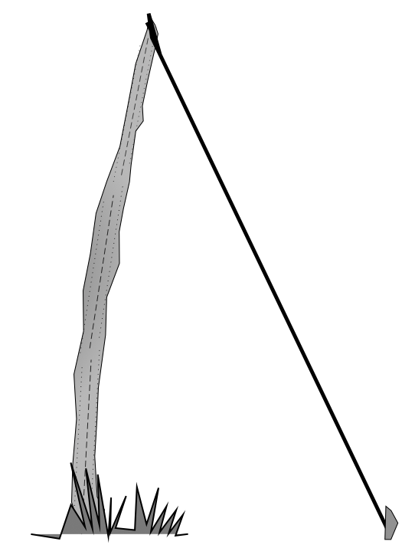

A simple “compass” made from string and a stick.

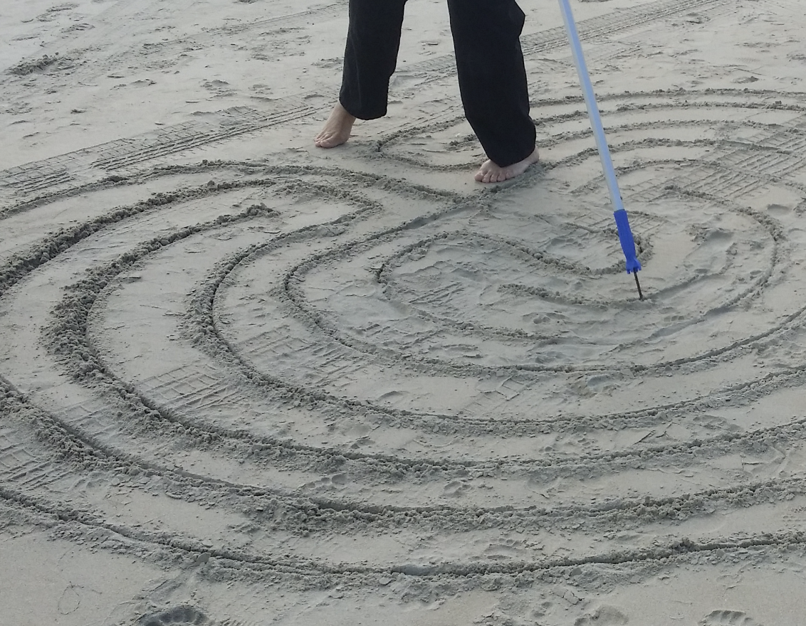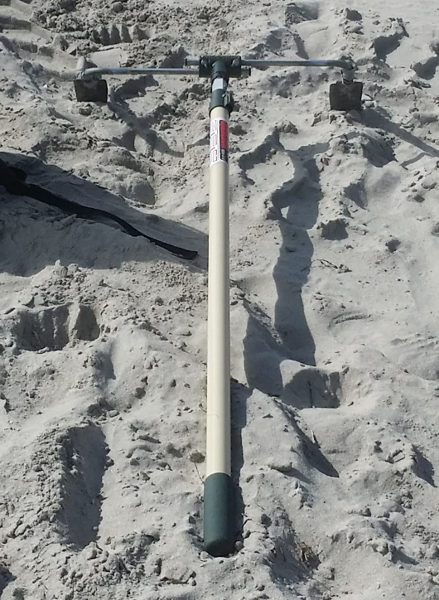

Making a labyrinth in the sand with a broom handle and metal point, and
a clever “twin groove” making tool made from two trowels and a paint roller.

5. MAKING THE LABYRINTH

- Build up your labyrinth simply by following each of the steps in the diagram below (you might like to sketch this out on paper or have a print-out of the diagram to have with you when you are marking your labyrinth out on the ground). Thanks are due to Jeff Saward for originally showing the steps that are presented in this diagram.
- SEED PATTERN. The first part of the labyrinth to mark out is what’s known as the ‘seed pattern’. As shown in the diagram, once this has been laid out, joining up everything else should flow very easily!

6. DEDICATING THE LABYRINTH

- After creating the labyrinth, and before walking it for the first time, it’s normal practice to dedicate or bless the labyrinth, offering a positive intention for all who will come to walk it. This may take the form of a few simple words or a prayer, if you follow a faith tradition. However, if you wish to dedicate your labyrinth, say or do whatever feels right for you.

- One form of words that you might like to use, or something similar, is as follows:

Thank you, labyrinth, for your power and mystery.
Thank you for welcoming and surprising all who come to walk you.
Thank you for holding and protecting those who approach you.
Teach them, inspire them, help them to grow, and enjoy your embracing.
Bless you. May your work touch the lives of many. May your perfect work in this place be done.

- Walking around the outside of the labyrinth, just holding good intentions for it and those who come to walk it in your heart and mind, is one other approach.

7. WALKING AND REFLECTING

- We’ll consider possible ways that a labyrinth can be walked in a later module. You may want to hold open a question as you approach the labyrinth, or simply try to calm your mind, perhaps by focusing on your breathing as you take each step. Don’t expect anything to happen as you walk – just “be” and be open to whatever may come to you.

- If you’re able to leave your labyrinth laid out for a while, you may want to return to walk it several times. Similarly, after resting for a while, even if your labyrinth can only be laid out for a short time, you may want to come back to walking it a second or even third time. Take every opportunity you can to experience coming to its center, resting there a while, and then returning out. Feel ready to sit or kneel at the center if you’re able to and feel led, to walk slowly, sometimes possibly stopping a while as you follow the path – just doing whatever seems right.

- After finishing your walk, we suggest reflecting on your experience. You may wish to write notes about your reflections, or think carefully about them for a while. Possible topics that you might want to reflect upon include:
  - How do you feel after your walk?
  - What surprised you about your walk?
  - What ideas, inspirations, reflections came to you while you were walking (if any)?
  - What do you feel you gained by walking a labyrinth?
  - What do you think that walking a labyrinth may offer for others?

8. BEING ‘HELD’ AS YOU WALK

- It’s valuable if possible to have someone to ‘hold’ you while you walk a labyrinth, at least on one occasion. We will be talking about the idea of ‘holding’ in another module, as this is at the heart of hosting or facilitating a labyrinth walk.

- Ideally, this holding would be by someone who has training as a labyrinth host, or at least understands what is meant by the concept of ‘holding sacred space’ (also explained in another module).

- If you cannot find someone who is able to hold you locally, please contact us. One of us will aim to hold you at the approximate time you plan to walk your labyrinth, whether or not we are able to be present via the Internet or not, and although we may be physically located many miles away.

9. FURTHER INFORMATION

- Find a labyrinth. The Worldwide Labyrinth Locator lists known labyrinths around the world that might include ones close to where you live that you may be able to walk. Visit https://labyrinthlocator.com/ to search your location. If you find anything that’s out-of-date, or discover any new labyrinths that aren’t listed, do let the folks who maintain the database know! At the time of writing, a phone app was in development, allowing another means to access the Locator.

- If you are unable to make a labyrinth that you can physically walk, you might want to consider making or drawing a finger labyrinth that you can ‘walk’ with your fingers, hands, or eyes.

- Further videos and other sources of information about making a labyrinth include:

  - Making a Chartres pattern labyrinth at home (The Labyrinth Society guide), https://labyrinthsociety.org/make-a-labyrinth

  - Sadelle Wiltshire Meditative Arts
https://www.sadellewiltshire.com/

  - Drawing the 3, 5, 7 and 11-Circuit Classical labyrinth form seed pattern (The Labyrinth Society video), https://www.youtube.com/watch?v=GkD8k-w4Yig

  - Creating a Chartres labyrinth with masking tape (Warren Lynn, CTS, Indianapolis, Indiana)
https://youtu.be/i33t89tnGfU

  - Creating a Chakra Vyhua labyrinth in 3 minutes! (Discover Labyrinths)
https://youtu.be/H5--pGSEbPY

See the YouTube channel of Discover Labyrinths, https://www.youtube.com/user/BiomorphicDotOrg/featured, for many more videos showing how to create and draw labyrinths, and more!

  - Creating a labyrinth marked out by stones (Syl Carson Bodhi Yoga)
https://youtu.be/RgPj_NeHdok

  - Making a canvas labyrinth (Rebecca Angel Maxwell)
https://youtu.be/zyo2O4H6Bjc

  - Make a plaster finger labyrinth (Lise Lotz)
https://youtu.be/_GE-UBdXbrg

  - How to draw a five circuit ‘medieval’ (Chartres) labyrinth, (The Labyrinth Society video), https://www.youtube.com/watch?v=f1m5-ygVdqc

  - Build a backyard labyrinth (illustrated guide with photographs for laying out a permanent labyrinth), https://www.instructables.com/id/Build-a-Backyard-Labyrinth/

  - Laying out a classical labyrinth (illustrated guide by Labyrinthos), http://www.labyrinthos.net/layout.html

  - Making an indoor labyrinth on carpet (University of Westminster video featuring renown labyrinth historian Jeff Saward), https://www.youtube.com/watch?v=A9Qaws3qNow

  - https://www.youtube.com/watch?v=EjWk6tcUplY Video showing how to draw the “Transition Labyrinth” in the sand (the Transition Labyrinth was designed by Jamie Edmonds, who shows how to draw it in this video)

  - Myth, History and Archeology of the Cretan Labyrinth (illustrated article), http://folklorethursday.com/folklore-of-archaeology/cretan-labyrinth-myth-history-archaeology/

  - Please note that most of these resources are in the English language.

